Dear Participant,

Welcome to The Leadership Circle Profile! This e-mail provides you with the information you need to complete your Leadership Circle Profile 360 survey. The survey process consists of three steps:

STEP ONE – RECEIVE YOUR LOGIN INVITATION & ACCESS THE SURVEY

On [ENTER DATE] you'll receive an email asking you to login to The Leadership Circle platform and create a password to access the survey site. The email arrives from notifications@theleadershipcircle.com, with the subject line: "Welcome to The Leadership Circle". If the email does NOT appear in your in-box, please check your SPAM/JUNK folder.

Start by clicking on the link in the email. If you’re a new user (have never been in our system before) you’ll be asked to Active Your Account by creating a password. Also, for new users, the first questions you encounter are demographic questions. These are used for TLC Research ONLY and information is never shared. There is a “prefer not to answer” option for each question. If you start typing the word “prefer”, the option will pop-up so you can select it. 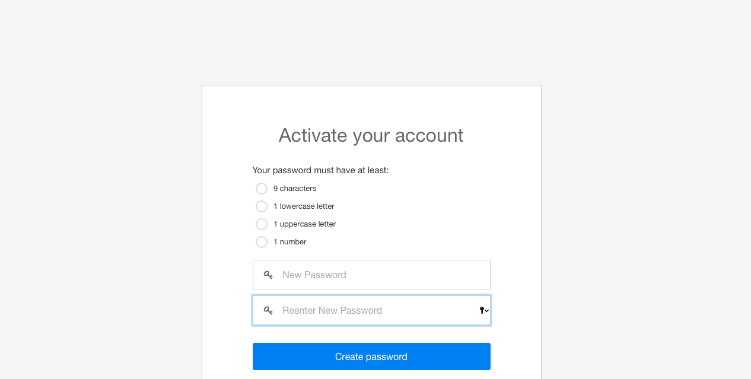

After clicking the link in your email, if you have been in our system as a prior user, and remember your password, simply add your email address and password to login. If you don’t remember your password, click the “Forgot/Create” link to create a new password and login to the survey.
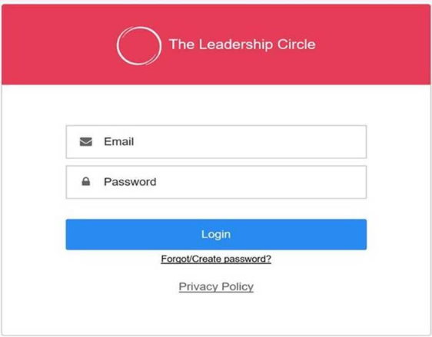

STEP TWO – IDENTIFY, NOTIFY AND SUBMIT YOUR EVALUATORS BY

Identify Your Evaluators

Part of the Leadership Circle Profile 360 process is receiving feedback from evaluators. When choosing evaluators, choose people who know you well; will provide candid feedback; have good motives for your development; understand your job responsibilities and areas of influence; and who can describe you in relation to the various roles you play on the job. You will want a minimum of 10 total evaluators, and ideally closer to 15, to ensure a robust data set. Therefore, try to identify at least 15-20 evaluators in the event some evaluators do not complete the assessment. The evaluator categories are defined below along with some guidance as to the ideal quantity of evaluators in each category for a robust data set:
Evaluator Categories:
Boss's Boss – Optional. May enter one or more. Only one completed survey is needed to view breakout data on your report.
Boss - This is the person who gives you your performance appraisal. You can enter more than one. Only one completed survey is needed to view breakout data on your report. Multiple completed surveys will merge.
Peer - These are people who know your work as a leader, but don’t report to you or have input into your evaluation. Three or more completed surveys are needed in this category in order to breakout data on your report.
Direct Report - These are people with whom you have input into their performance evaluations. We recommend including everyone who reports directly to you as well as anyone with whom you engage in an indirect supervisory capacity (as is increasingly the case in a complex, matrixed environment.) Three or more completed surveys are needed in this category in order to breakout data on your report.
Other - These are people who bear witness to your leadership but do not fit into any of the other categories. Others might include those in other organizations, outside collaborators, close associates, constituents, vendors, or respected people in your circle of interaction such as charity groups you work with. Three or more completed surveys are needed in this category in order to breakout data on your report.
NOTE: Feedback from your Boss or Boss’s Boss is not anonymous and will be identifiable. Feedback from Direct Reports, Peers, and Others is considered anonymous and will not be reported by category, if there are fewer than three responses in the category.

IMPORTANT - Notify Your Evaluators
Once you have determined your evaluators for each category, we recommend you send them an email letting them know you identified them as an evaluator and ask them to contribute to the survey. There is a template at the bottom of this email titled, “Sample Email to Evaluators” for you to customize and send to each evaluator, before setting them up in the system.

SETUP (add) Your Evaluators
Begin adding your Evaluators by clicking the “Evaluator Setup” button, on the right side of the screen.

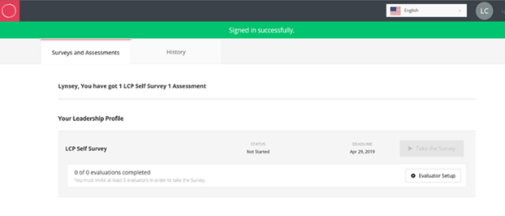
Enter an email address, last name, and first name for each evaluator. Be sure to spell evaluator email addresses correctly or they will not be notified. Select the language in which you want them to receive the survey (defaults to English), and select their relationship to you, by clicking the drop-down box. The login email will automatically go to the Evaluator when you click, “Add Evaluator”.

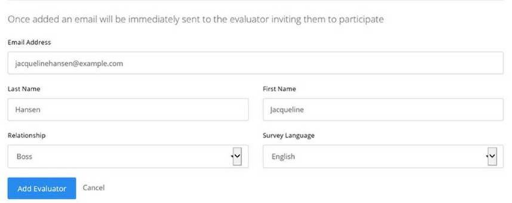

Repeat the steps for each Evaluator you want to add. While you may continue to submit additional evaluators throughout the survey window, please submit your evaluators by [ENTER DATE], to ensure all evaluators have time to complete the survey.

STEP THREE – COMPLETE YOUR SELF-SURVEY

After adding at least five evaluators, the “Take the Survey” button becomes active on the Survey List homepage. Click this button to begin your self-assessment.

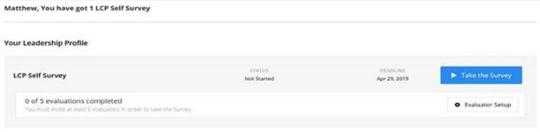

Answer the 124 questions pertaining to yourself. Completing your self-survey will take approximately 25 minutes. This data will be used to evaluate your perception of self, compared to the perception held by your evaluators.
We value the opportunity to work with you. Please don’t hesitate to reach out with questions, or if you should encounter any technical difficulties. Our phone is: [ADD] and our email address is: [ADD].

Warm Regards,

----------------------

SEE SAMPLE EMAIL TO EVALUATORS BELOW
SAMPLE EMAIL TO EVALUATORS:
Please customize and send this email to each of your evaluators BEFORE setting them up in the system.
Dear ENTER NAME,
I am participating in The Leadership Circle Profile, a 360-degree assessment tool designed to measure my current leadership skills and develop my leadership potential. I am asking for your feedback because I value our relationship and your perspective.
Providing feedback involves completing an online survey. Your feedback is entirely confidential, and I will not know who has or has not completed the survey, unless you are my Boss or Boss’s Boss.
You will receive an e-mail from notifications@theleadershipcircle.com with a link for creating a password.

Start by clicking on the link in the email. If you’re a new user (have never been in our system before) you’ll be asked to “Active Your Account” by creating a password. If you have been in our system as a prior user, but don’t remember your password after clicking the link, click the “Forgot/Create” link to create a new password and login to the survey.
Completing the entire survey takes approximately 25 minutes of your time. If you must step away before completing the survey, click "logout". You can log back into the survey at any time and be taken right back to the place you left off. The survey completion deadline is: [ENTER DATE].
Should you have any questions or experience technical difficulty with the survey, please contact The Leadership Circle using support@theleadershipcircle.com.

Warm Regards,
YOUR NAME

