All Survey Takers receive the initial Welcome email:
Dear <name>,

Welcome to the Collective Leadership Assessment™.

Your account is set up and you can begin at any time. The deadline for completing
the survey is <deadline>.

Here is the information you need to access the survey.
Web Address:
https://survey.theleadershipcircle.com/abcdefg

Please contact me at the e-mail address below with any questions.

Warm regards,

<Consultant name>
<Consultant email>

- If the Survey Taker already has an existing Account – the link will take
them directly into the Survey, showing them “My Active Survey’s”.

- If they are old survey taker – the link will take them directly to the My Active
Survey page.
4. If they are a new Survey Taker they will be asked to enter a PW and do demographics.
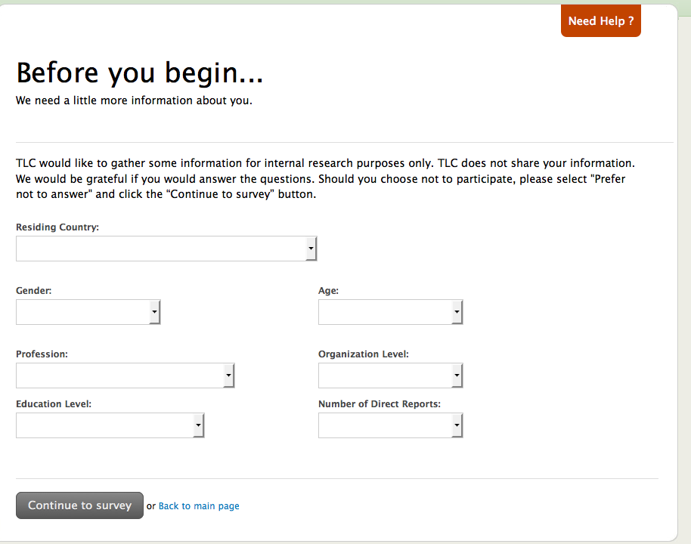
// End Template

