Leadership Circle Profile ADD a Participant to a Project

Web address is https://project-center.theleadershipcircle.com

You have just created a new Project and you are now ready to add your Participants

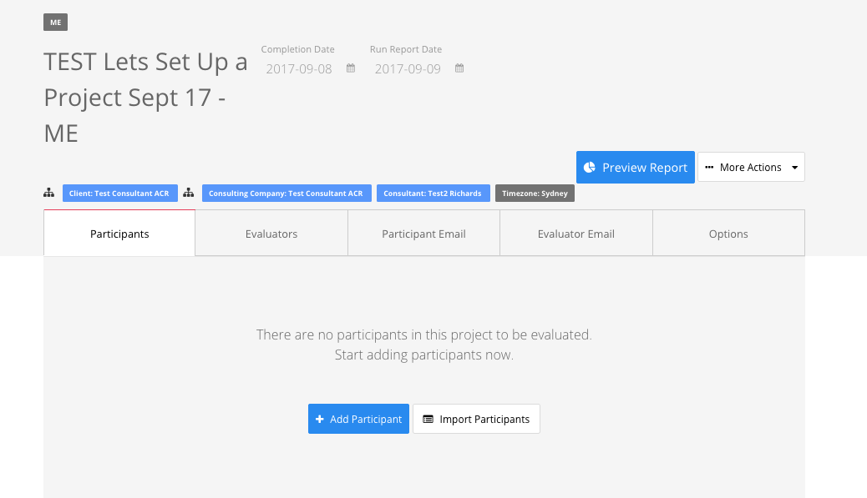

Click the Blue “+ Add Participant” button. Enter the details of your Participant. Click Save Changes.

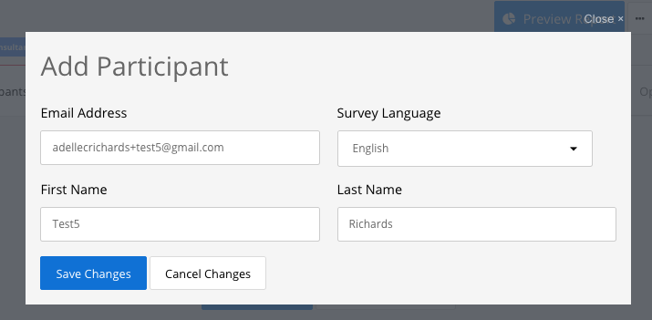

Your Participant is now setup.
