Intro to Collective Leadership Assessment™

You can use the template below to launch the Collective Leadership Assessment™ with your clients. We encourage you to make changes as you see fit.

Dear ENTER NAME,

As we prepare for TEAM/ COMPANY NAME Collective Leadership Assessment™ (CLA), below are some helpful tips to make your experience great! Please take the time to read the following to ensure sure you are ready.

Step One:
You will receive an email from notifications@theleadershipcircle.com on INSERT LAUNCH DATE. To ensure the email doesn't deliver to spam or junk, we suggest adding this email address notifications@theleadershipcircle.com to your approved sender list.
In the email, you will find a link to the survey. If you're a first-time user, the "Activate Your Account" screen will appear, prompting you to create a password and log in. You will be asked to input demographic information before beginning the CLA. Your demographic information is used solely for Leadership Circle research. If you don't want to provide your demographic information, each question has a "prefer not to answer" option
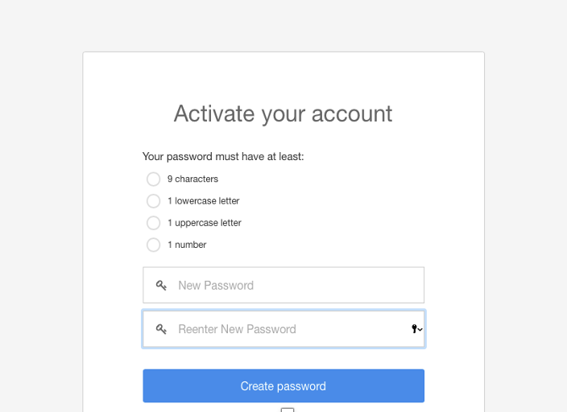

If you have previously completed a survey with Leadership Circle, simply log in using your email address and password. If you forget your password, use the "Forgot/Create password" link to set up a new one.
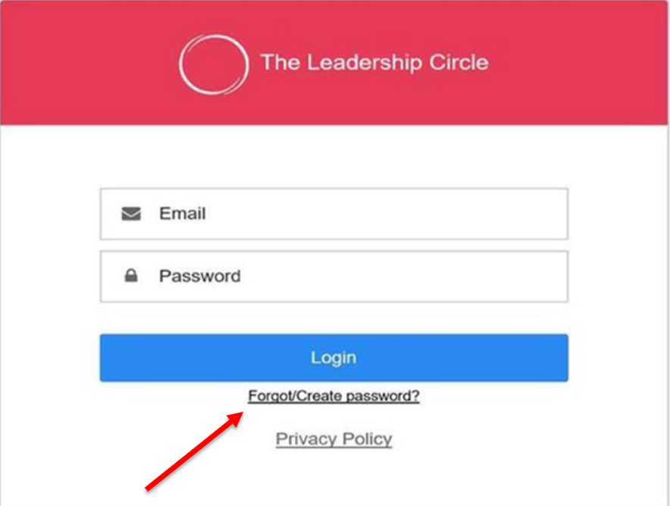

Step Two:

Once you log into Project Center, click the "Take Survey" button. The survey takes about 15- 20 minutes to complete. You are welcome to log in out as many times as needed; the survey will auto-save your completed answers.

Please read each section carefully, as you will answer the same set of questions twice. Section 1 is going to ask you about your view of the CURRENT collective leadership effectiveness. Section 2 is going to ask you about your IDEAL collective leadership effectiveness.

Step Three:

Submit your completed survey. Note, you are able review and edit your responses before submitting.

Warm Regards,

YOUR NAME & CONTACT INFO

